Decagonal Pyramid
# Source: AI Source: Provided by: [Data Path: Persons Table -> ID Column: 1, Name_En Column: Motasem Essam] -> From: [ChatGPT] on [7/25/2026]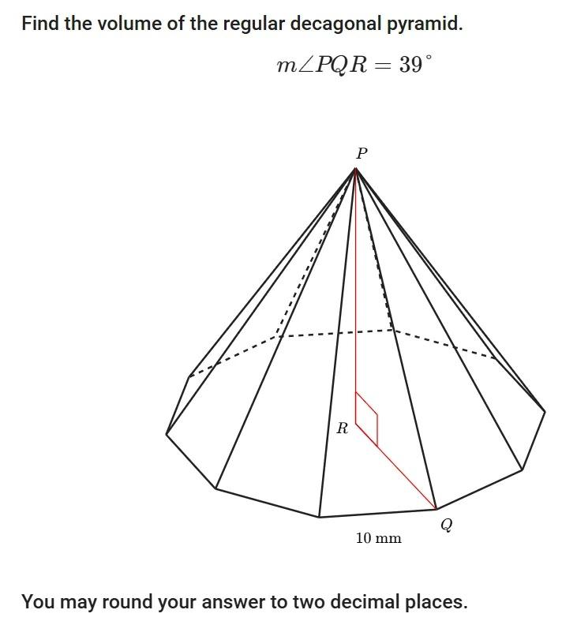

Definition
# Source: AI Source: Provided by: [Data Path: Persons Table -> ID Column: 1, Name_En Column: Motasem Essam] -> From: [ChatGPT] on [7/25/2026]
A Decagonal Pyramid is a three-dimensional geometric solid with a decagonal base (a polygon with ten sides) and ten triangular lateral faces that meet at a single common point called the apex.
The base can be a regular or irregular decagon. Depending on the position of the apex, the pyramid can be right or oblique.

Simple Definition
# Source: AI Source: Provided by: [Data Path: Persons Table -> ID Column: 1, Name_En Column: Motasem Essam] -> From: [ChatGPT] on [7/25/2026]
A Decagonal Pyramid is a solid with:
- One ten-sided polygon as its base.
- Ten triangular lateral faces.
- One apex where all ten triangular faces meet.

Classification Tree
# Source: AI Source: Provided by: [Data Path: Persons Table -> ID Column: 1, Name_En Column: Motasem Essam] -> From: [ChatGPT] on [7/25/2026]
Solid Geometry
└── Types of Solids
└── Pyramids
└── Types of Pyramids
└── Decagonal Pyramid
├── Regular Decagonal Pyramid
└── Irregular Decagonal Pyramid
According to the position of the apex:
- Right Decagonal Pyramid
- Oblique Decagonal Pyramid

Key Characteristics
# Source: AI Source: Provided by: [Data Path: Persons Table -> ID Column: 1, Name_En Column: Motasem Essam] -> From: [ChatGPT] on [7/25/2026]
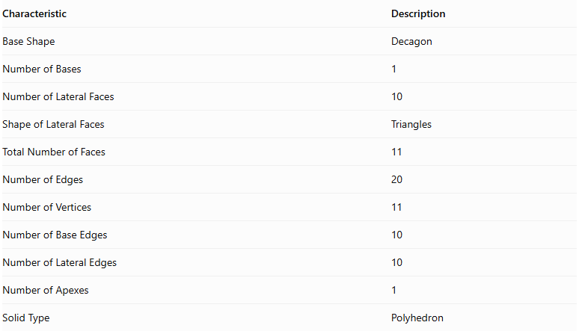
Characteristic | Description
Base Shape | Decagon
Number of Bases | 1
Number of Lateral Faces | 10
Shape of Lateral Faces | Triangles
Total Number of Faces | 11
Number of Edges | 20
Number of Vertices | 11
Number of Base Edges | 10
Number of Lateral Edges | 10
Number of Apexes | 1
Solid Type | Polyhedron

Regular Decagonal Pyramid
# Source: AI Source: Provided by: [Data Path: Persons Table -> ID Column: 1, Name_En Column: Motasem Essam] -> From: [ChatGPT] on [7/25/2026]
A Regular Decagonal Pyramid has a regular decagon as its base, with the apex directly above the center of the base in a right pyramid.
Its ten lateral faces are congruent isosceles triangles.

Geometric Representation
# Source: AI Source: Provided by: [Data Path: Persons Table -> ID Column: 1, Name_En Column: Motasem Essam] -> From: [ChatGPT] on [7/25/2026]
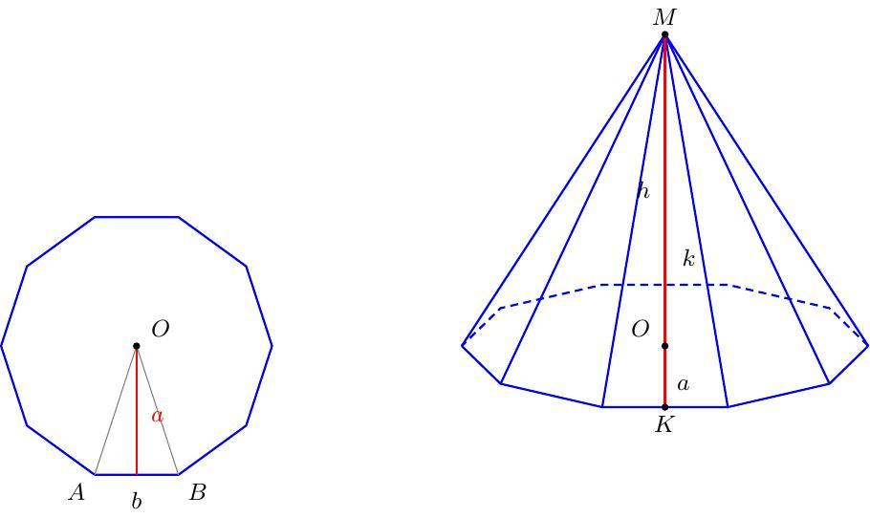

Main Components
# Source: AI Source: Provided by: [Data Path: Persons Table -> ID Column: 1, Name_En Column: Motasem Essam] -> From: [ChatGPT] on [7/25/2026]
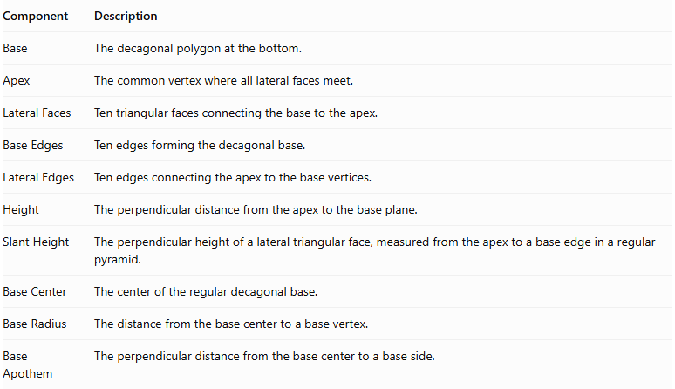
Component | Description
Base | The decagonal polygon at the bottom.
Apex | The common vertex where all lateral faces meet.
Lateral Faces | Ten triangular faces connecting the base to the apex.
Base Edges | Ten edges forming the decagonal base.
Lateral Edges | Ten edges connecting the apex to the base vertices.
Height | The perpendicular distance from the apex to the base plane.
Slant Height | The perpendicular height of a lateral triangular face, measured from the apex to a base edge in a regular pyramid.
Base Center | The center of the regular decagonal base.
Base Radius | The distance from the base center to a base vertex.
Base Apothem | The perpendicular distance from the base center to a base side.

Mathematical Representations and Formulas
# Source: AI Source: Provided by: [Data Path: Persons Table -> ID Column: 1, Name_En Column: Motasem Essam] -> From: [ChatGPT] on [7/25/2026]
Let:
- $a$ = side length of the regular decagonal base.
- $h$ = vertical height of the pyramid.
- $l$ = slant height of a lateral face.
- $r$ = apothem of the base.
- $R$ = circumradius of the base.
- $B$ = base area.
- $P$ = base perimeter.

A. Base Perimeter
# Source: AI Source: Provided by: [Data Path: Persons Table -> ID Column: 1, Name_En Column: Motasem Essam] -> From: [ChatGPT] on [7/25/2026]
For a regular decagon:
$$P=10a$$

B. Base Area
# Source: AI Source: Provided by: [Data Path: Persons Table -> ID Column: 1, Name_En Column: Motasem Essam] -> From: [ChatGPT] on [7/25/2026]
$$B=\frac{1}{2}Pr$$
$$B=5ar$$
Using the side length directly:
$$B=\frac{10a^{2}}{4tan({18}^{∘})}$$
$$B=\frac{5a^{2}}{2tan({18}^{∘})}$$

C. Base Apothem
# Source: AI Source: Provided by: [Data Path: Persons Table -> ID Column: 1, Name_En Column: Motasem Essam] -> From: [ChatGPT] on [7/25/2026]
$$r=\frac{a}{2tan({18}^{∘})}$$

D. Circumradius
# Source: AI Source: Provided by: [Data Path: Persons Table -> ID Column: 1, Name_En Column: Motasem Essam] -> From: [ChatGPT] on [7/25/2026]
$$R=\frac{a}{2sin({18}^{∘})}$$

E. Height and Slant Height
# Source: AI Source: Provided by: [Data Path: Persons Table -> ID Column: 1, Name_En Column: Motasem Essam] -> From: [ChatGPT] on [7/25/2026]
For a regular right decagonal pyramid:
$$l=\sqrt{h^{2}+r^{2}}$$

F. Lateral Surface Area
# Source: AI Source: Provided by: [Data Path: Persons Table -> ID Column: 1, Name_En Column: Motasem Essam] -> From: [ChatGPT] on [7/25/2026]
The lateral surface consists of ten congruent triangular faces.
$$LSA=\frac{1}{2}Pl$$
$$LSA=5al$$

G. Total Surface Area
# Source: AI Source: Provided by: [Data Path: Persons Table -> ID Column: 1, Name_En Column: Motasem Essam] -> From: [ChatGPT] on [7/25/2026]
$$TSA=B+LSA$$
$$TSA=5ar+5al$$

H. Volume
# Source: AI Source: Provided by: [Data Path: Persons Table -> ID Column: 1, Name_En Column: Motasem Essam] -> From: [ChatGPT] on [7/25/2026]
$$V=\frac{1}{3}Bh$$
$$V=\frac{5arh}{3}$$

I. Number of Faces, Edges, and Vertices
# Source: AI Source: Provided by: [Data Path: Persons Table -> ID Column: 1, Name_En Column: Motasem Essam] -> From: [ChatGPT] on [7/25/2026]
For a pyramid with an $n$-sided base:
$$F=n+1$$
$$E=2n$$
$$V=n+1$$
For a Decagonal Pyramid, $n=10$:
- Faces = 11
- Edges = 20
- Vertices = 11

Worked Examples

Example 1: Calculate the Number of Faces, Edges, and Vertices
# Source: AI Source: Provided by: [Data Path: Persons Table -> ID Column: 1, Name_En Column: Motasem Essam] -> From: [ChatGPT] on [7/25/2026]
Given:
$$n=10$$
Faces:
$$F=10+1=\boxed{11}$$
Edges:
$$E=2(10)=\boxed{20}$$
Vertices:
$$V=10+1=\boxed{11}$$

Example 2: Calculate the Base Perimeter
# Source: AI Source: Provided by: [Data Path: Persons Table -> ID Column: 1, Name_En Column: Motasem Essam] -> From: [ChatGPT] on [7/25/2026]
Given:
$$a=5 cm$$
$$P=10(5)$$
$$\boxed{P=50 cm}$$

Example 3: Calculate the Base Area
# Source: AI Source: Provided by: [Data Path: Persons Table -> ID Column: 1, Name_En Column: Motasem Essam] -> From: [ChatGPT] on [7/25/2026]
Given a regular decagonal base with:
$$a=4 cm$$
$$B=\frac{5(4)^{2}}{2tan({18}^{∘})}$$
$$\boxed{B≈123.11{ cm}^{2}}$$

Example 4: Calculate the Volume
# Source: AI Source: Provided by: [Data Path: Persons Table -> ID Column: 1, Name_En Column: Motasem Essam] -> From: [ChatGPT] on [7/25/2026]
Given:
$$B=123.11{ cm}^{2}$$
$$h=12 cm$$
$$V=\frac{1}{3}(123.11)(12)$$
$$\boxed{V≈492.44{ cm}^{3}}$$

Example 5: Calculate the Lateral and Total Surface Areas
# Source: AI Source: Provided by: [Data Path: Persons Table -> ID Column: 1, Name_En Column: Motasem Essam] -> From: [ChatGPT] on [7/25/2026]
Given:
$$a=4 cm, l=8 cm$$
Perimeter:
$$P=10(4)=40 cm$$
Lateral surface area:
$$LSA=\frac{1}{2}(40)(8)$$
$$\boxed{LSA=160{ cm}^{2}}$$
Total surface area:
$$TSA=123.11+160$$
$$\boxed{TSA≈283.11{ cm}^{2}}$$

Comparison with Related Pyramids
# Source: AI Source: Provided by: [Data Path: Persons Table -> ID Column: 1, Name_En Column: Motasem Essam] -> From: [ChatGPT] on [7/25/2026]
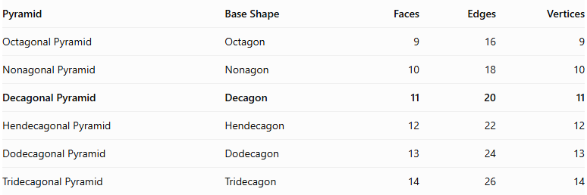
Pyramid | Base Shape | Faces | Edges | Vertices
Octagonal Pyramid | Octagon | 9 | 16 | 9
Nonagonal Pyramid | Nonagon | 10 | 18 | 10
Decagonal Pyramid | Decagon | 11 | 20 | 11
Hendecagonal Pyramid | Hendecagon | 12 | 22 | 12
Dodecagonal Pyramid | Dodecagon | 13 | 24 | 13
Tridecagonal Pyramid | Tridecagon | 14 | 26 | 14

Constructing Decagonal Pyramid in Solid Geometry

Instruments Used
# Source: AI Source: Provided by: [Data Path: Persons Table -> ID Column: 1, Name_En Column: Motasem Essam] -> From: [ChatGPT] on [7/25/2026]
The construction uses physical geometric drawing instruments rather than coordinate-based methods.
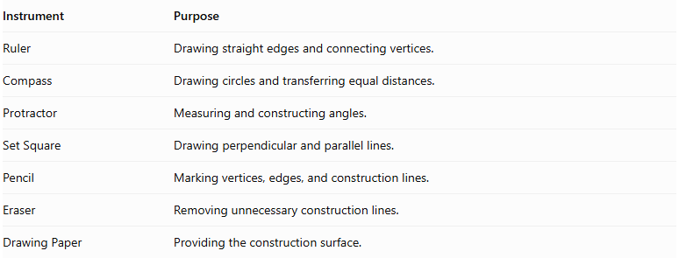
Instrument | Purpose
Ruler | Drawing straight edges and connecting vertices.
Compass | Drawing circles and transferring equal distances.
Protractor | Measuring and constructing angles.
Set Square | Drawing perpendicular and parallel lines.
Pencil | Marking vertices, edges, and construction lines.
Eraser | Removing unnecessary construction lines.
Drawing Paper | Providing the construction surface.

Construction Procedures

Base-Based Construction
# Source: AI Source: Provided by: [Data Path: Persons Table -> ID Column: 1, Name_En Column: Motasem Essam] -> From: [ChatGPT] on [7/25/2026]
- Draw a decagonal base using a ruler, compass, and protractor.
- Identify and mark its ten vertices.
- Determine the position of the apex above or away from the base.
- Connect the apex to each of the ten base vertices.
- Complete the ten triangular lateral faces.
- Darken the visible edges and use dashed lines for hidden edges.

Apex-Based Construction
# Source: AI Source: Provided by: [Data Path: Persons Table -> ID Column: 1, Name_En Column: Motasem Essam] -> From: [ChatGPT] on [7/25/2026]
- Mark the intended apex position.
- Draw the decagonal base beneath the apex.
- Identify the ten base vertices.
- Connect each base vertex to the apex.
- Complete the lateral triangular faces.

Vertex-Connection Construction
# Source: AI Source: Provided by: [Data Path: Persons Table -> ID Column: 1, Name_En Column: Motasem Essam] -> From: [ChatGPT] on [7/25/2026]
- Construct the ten vertices of the decagonal base.
- Mark the apex as the eleventh vertex.
- Connect the apex to all ten base vertices.
- Connect consecutive base vertices to complete the decagonal base.
- Check that all edges and faces form a closed solid.

Edge-Based Construction
# Source: AI Source: Provided by: [Data Path: Persons Table -> ID Column: 1, Name_En Column: Motasem Essam] -> From: [ChatGPT] on [7/25/2026]
- Draw the ten edges of the decagonal base.
- Determine the ten lateral edges extending from the base vertices to the apex.
- Construct and connect the lateral edges.
- Complete the triangular lateral faces.

Face-Based Construction
# Source: AI Source: Provided by: [Data Path: Persons Table -> ID Column: 1, Name_En Column: Motasem Essam] -> From: [ChatGPT] on [7/25/2026]
- Construct the decagonal base.
- Draw ten triangular faces around the base.
- Connect the corresponding vertices and edges.
- Ensure that all ten triangular faces meet at the apex.

Net-Based Construction
# Source: AI Source: Provided by: [Data Path: Persons Table -> ID Column: 1, Name_En Column: Motasem Essam] -> From: [ChatGPT] on [7/25/2026]
- Draw one decagonal base.
- Construct ten triangular faces around the decagon.
- Add tabs if necessary for physical assembly.
- Cut out the net.
- Fold the triangular faces upward.
- Join their edges to form the decagonal pyramid.
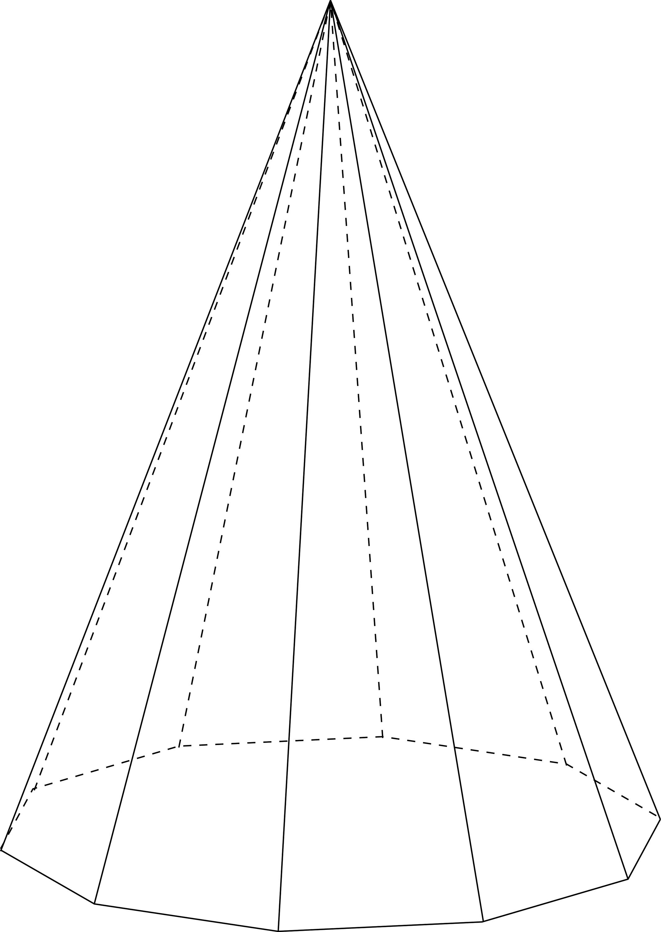

Applications
# Source: AI Source: Provided by: [Data Path: Persons Table -> ID Column: 1, Name_En Column: Motasem Essam] -> From: [ChatGPT] on [7/25/2026]
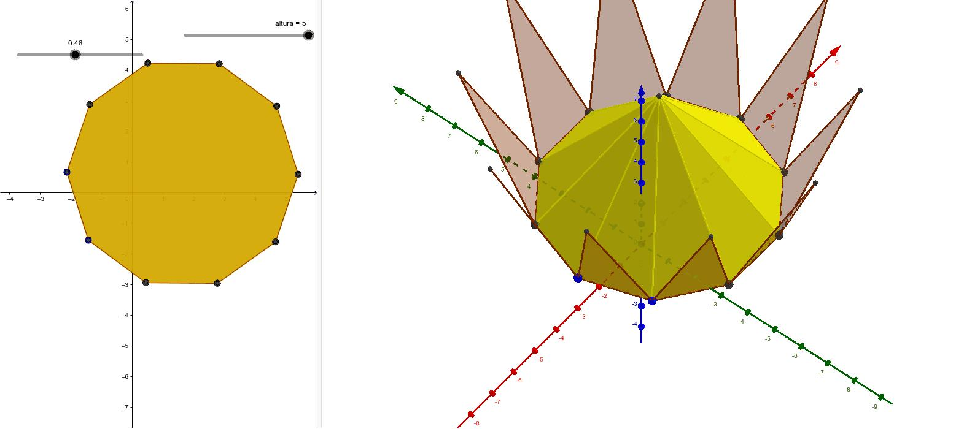
- Architecture: Decorative roof structures and designs with decagonal bases.
- Mathematical Models: Teaching polygonal pyramids and three-dimensional geometry.
- Sculpture: Geometric sculptures and decorative objects.
- Engineering: Studying triangular face arrangements and structural geometry.

Key Points
# Source: AI Source: Provided by: [Data Path: Persons Table -> ID Column: 1, Name_En Column: Motasem Essam] -> From: [ChatGPT] on [7/25/2026]
- A Decagonal Pyramid has one decagonal base.
- It has ten triangular lateral faces.
- All ten lateral faces meet at one apex.
- It has 11 faces, 20 edges, and 11 vertices.
- Its volume is one-third of the product of its base area and perpendicular height.
- A regular right Decagonal Pyramid has a regular decagonal base and ten congruent isosceles triangular lateral faces.

Conclusion
# Source: AI Source: Provided by: [Data Path: Persons Table -> ID Column: 1, Name_En Column: Motasem Essam] -> From: [ChatGPT] on [7/25/2026]
A Decagonal Pyramid is a polyhedron characterized by a ten-sided polygonal base and ten triangular lateral faces meeting at a single apex. It has 11 faces, 20 edges, and 11 vertices, making it an important member of the polygonal pyramid family.

